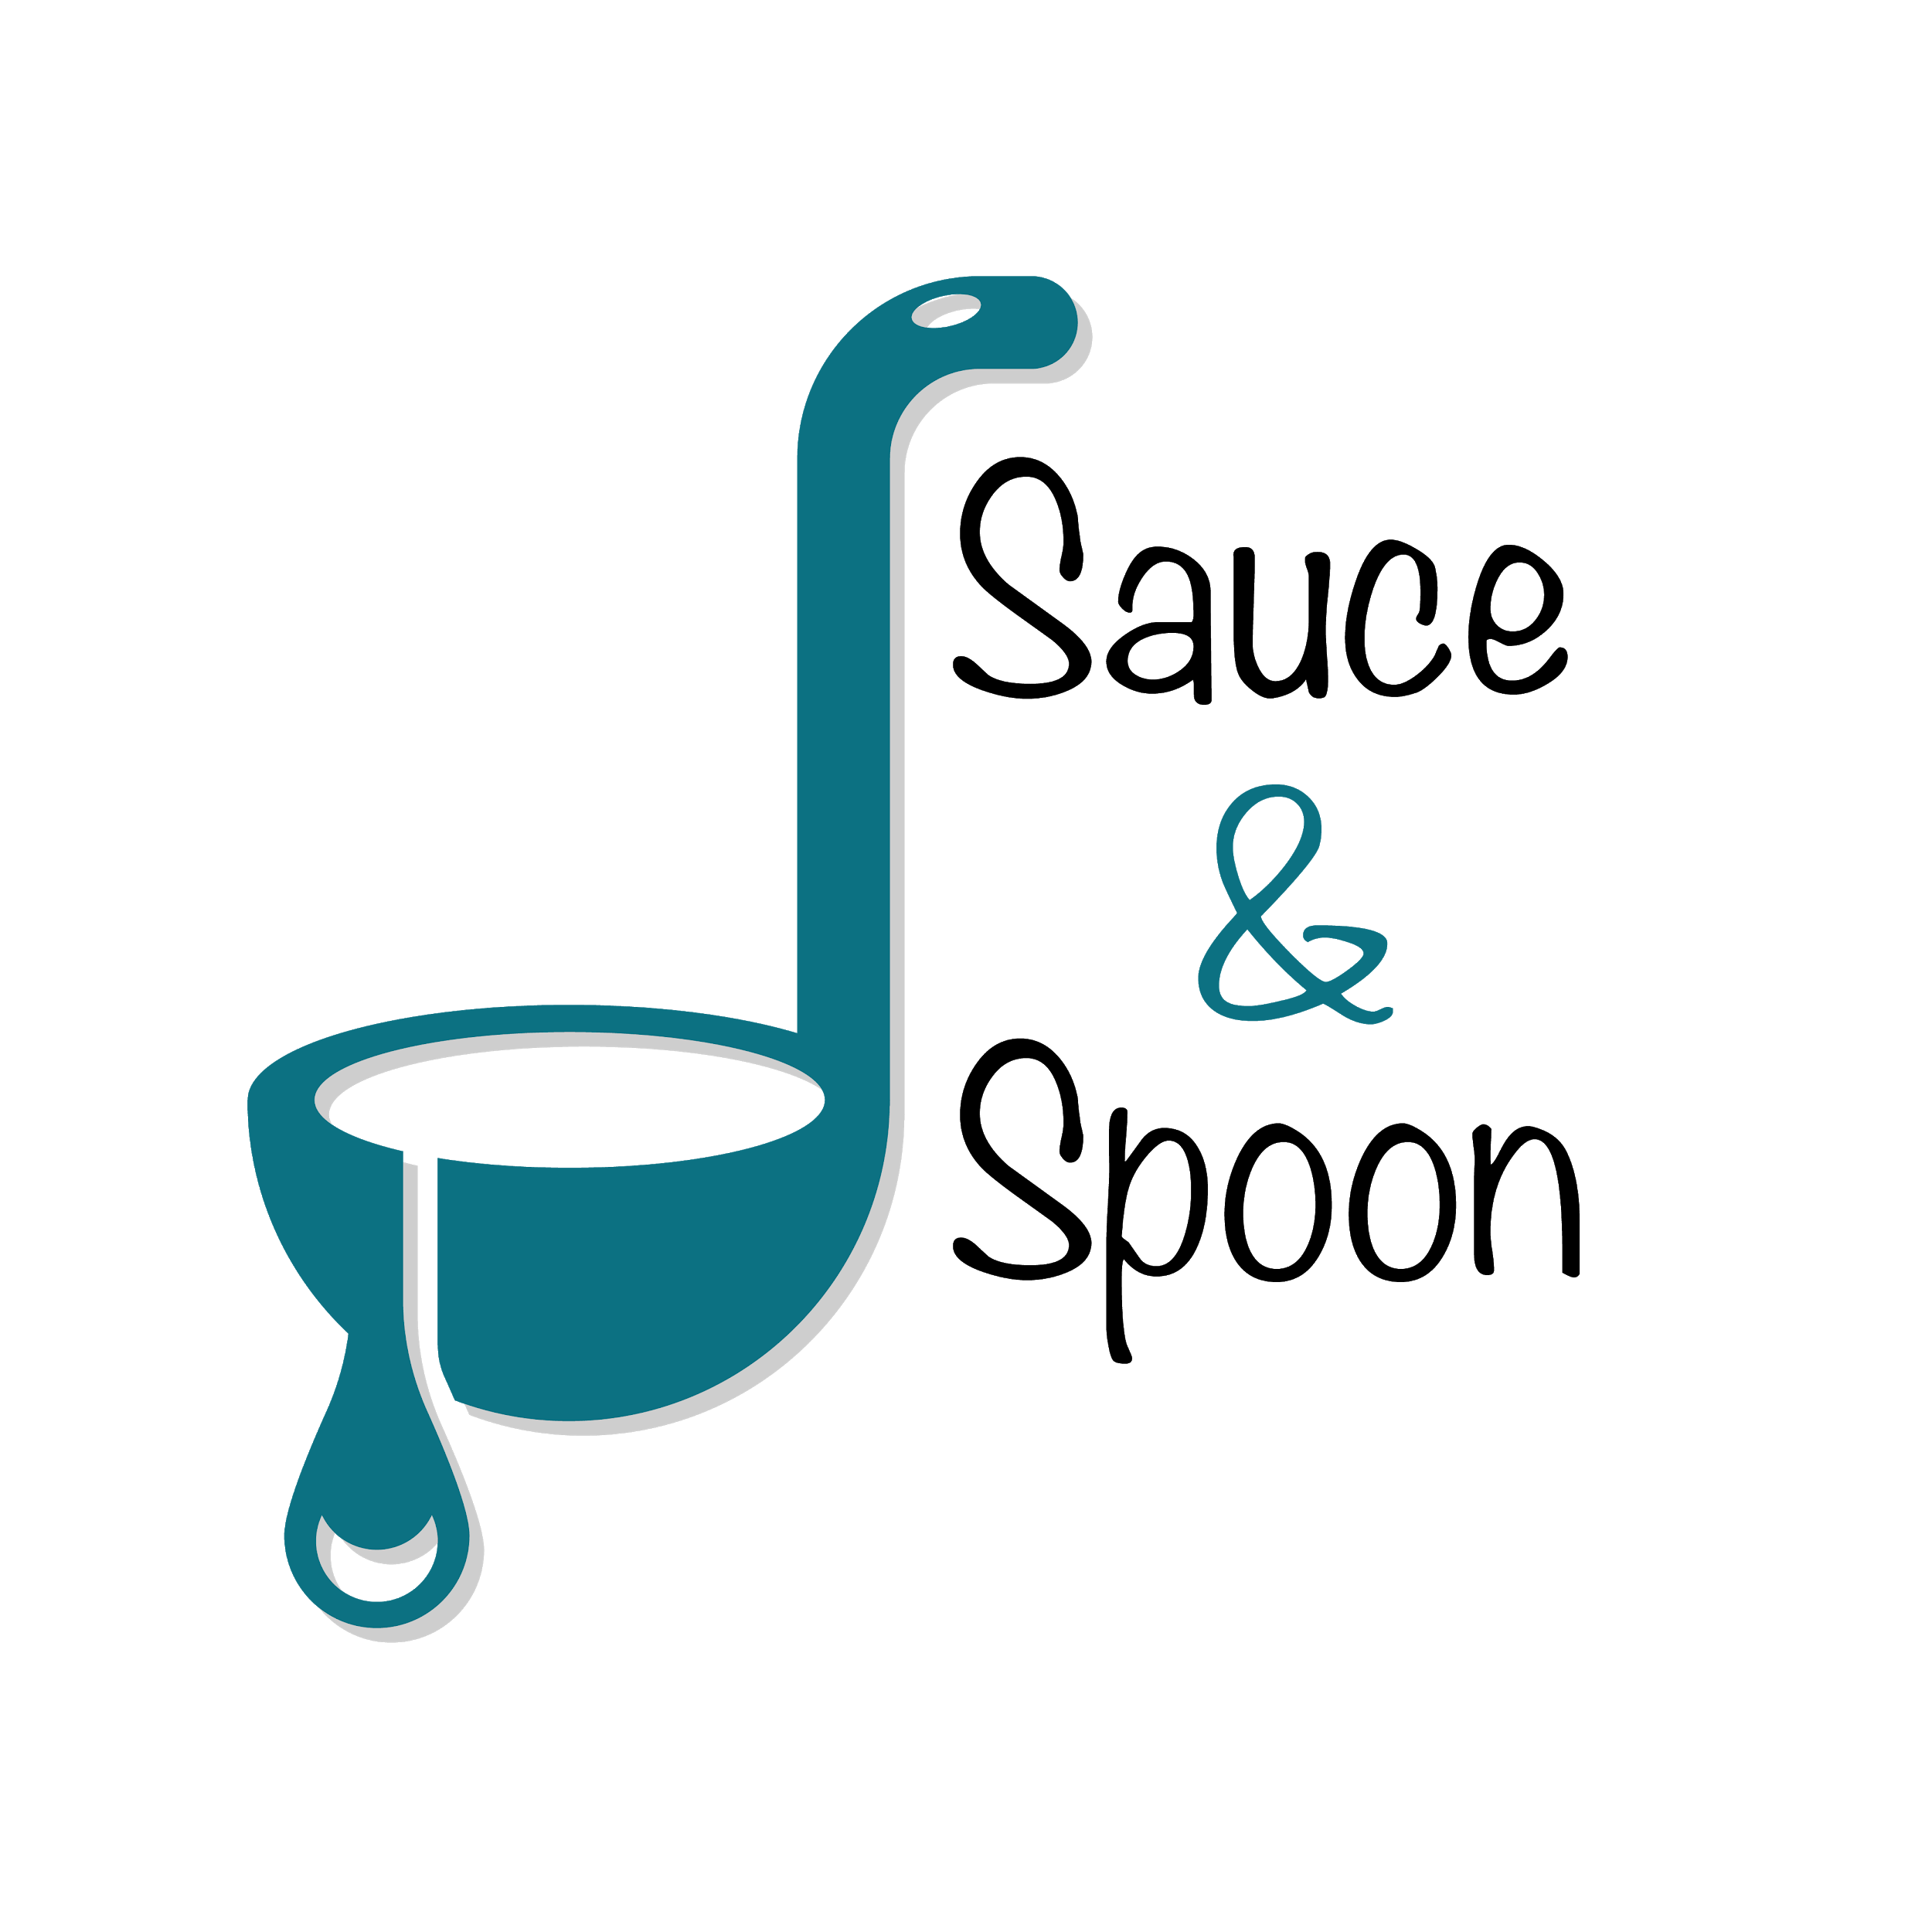

Project Charter: Menu Tablets

DATE: 14/03/21

|  |
| --- |
| **Project Summary** |
| Sauce & Spoon goal is to reduce average table turn times by 30 minutes by implementing a digital menu and point-of-sale (POS) system. The pilot project will be implemented at bar area in Sauce & Spoon North and Sauce & Spoon Downtown in April. |

|  |
| --- |
| **Project Goals** |
| * Decrease average table turn time by approximately 30 minutes by the end of the second quarter (Q2), resulting in decreased customer wait time * Increase average check total to $75 by selling more appetizers and beverages by the end of Q2, resulting in increased profits * Cut food waste by 25% by the end of second Quarter (Q2) by integrating kitchen order notification, resulting in reduced cost * Increase daily guest counts by 10% by reducing overall dining time by the end of the second quarter (Q2) * Increase average 15% overall appetizers sales, with the North location targeted for a 10% increase and the Downtown location targeted for a 20% increase by June by implementing coupon and promote appetizers. * Reduce bad reviews by TBD * Reduce employee burnout and turnover by TBD * Increase profit margin by TBD |

|  |
| --- |
| **Deliverables** |
| * Tablets installed in the bar area of two restaurant locations. * Tablets has feature to notify kitchen on order and order change. * Tablets has feature to record customer order data. * Clear data points to track revenue increases, menu sales, and coupon usage. * Tablets has feature to promote menu item as an add-on, and you can display a coupon. * Tablets are integrated to existing POS system and host software. * All server, cashier, and kitchen staffs are fully trained on the new system. |

|  |
| --- |
| **Scope and Exclusion** |
| **In-Scope:**   * Tablets procurement * System configuration and integration * Staff Training * Tablets to be installed at bar section in two restaurant locations, Sauce & Spoon North and Sauce & Spoon Downtown. * Tablet Custom menu branding, design, and upload.   **Out-of-Scope:**   * Company Policy |

|  |
| --- |
| **Benefits & Costs** |
| **Benefits:**   * Decrease average table turn time by approximately 30 minutes * Increase average check total to $75 * Cut food waste by 25% * Increase daily guest counts by 10% * Increase average 15% overall appetizers sales   **Costs:**   * Training material & fees: $10,000 * Hardware and Software implementation across locations: $30,000 * Maintenance (IT fees through EOY): $5,000 * Updated website and menu design fee: $5,000 * Other customization fees: $550 |

|  |
| --- |
| **Appendix:** |
| * Misalignment on decrease guest wait time as a separate goal: we decided to remove from project charter. * Misalignment on Appetizers sales increase goal: so we averaged the increase goals and set individual goal for each location. * Misalignment on whether and how we can reallocate payroll staff budget to hire kitchen staff: we’ll collect more data to ensure we make the right decision * Misalignment on the policy change to be out of scope: we decided to keep it as out of scope and discuss separately in operation forum. * Misalignment on expand project scope to all dining section: we convince Operation director and owner to stay in the original scope due to concern on timeline, risk, and budget. |